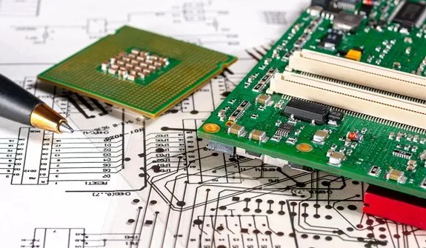
The realization of the different parts can be done independently.
I- Design a system allowing the autonomous navigation of the robot in the picking path.
- Develop a SLAM mapping algorithm under ROS to construct a 10m x 5m simulated agricultural scene map.
- Combined with point 3, the “zero spin radius” characteristic of the Mecanum wheel (spin radius ≤0 mm).
- Design an A* path planning algorithm suitable for the crop row spacing.
- Realize the robot’s autonomous cruise along the planting row.
- Ultrasonic obstacle avoidance
- Precision of docking at picking points.
- Adapt the navigation to the narrow working space of agricultural scenarios such as greenhouses.

II. Development of Crop Recognition and Maturity Judgment Module
- Collect data on simulated crops commonly used in competitions (such as strawberries and tomatoes).
- Construct a crop image dataset with "unripe-ripe-overripe" labels.
- Use YOLOv5s/MobileNet lightweight deep learning models to develop crop recognition and maturity classification algorithms.
- Improve agricultural scene adaptability through transfer learning (pre-trained based on COCO dataset), output 2D coordinates of RGB images and 3D depth positions of mature crops, ensuring recognition accuracy ≥92% and single-frame processing time ≤0.3s.
- Combined with the 60° field of view of the camera module.

III. Precision Picking Control of Robotic Arm and Adaptive Gripper
- Complete the hand-eye calibration of the 3-4 DOF robot arm based on ROS hand-eye calibration tools.
- Establish a coordinate mapping model of "depth camera-robotic arm base coordinate-gripper end".
- Convert the 3D position of crops into robotic arm motion commands.
- Develop picking trajectory planning logic through Python programming interface.
- Control the robotic arm to act according to the process of "approaching crops
→ adaptive gripper opening → precise clamping (automatic force adjustment according to crop diameter) → lifting off the plant → transferring to the storage box".
- Optimize the gripper control strategy: adjust the clamping force through pressure sensor feedback for different crops such as strawberries (diameter 2-4cm) and tomatoes (4- 6cm) to avoid crop damage or falling.

IV. System Integration and Performance Optimization
- Integrate the voice control function (based on TTL serial voice module, 5V power supply), support voice commands such as "start picking", "pause picking", and "switch crop type" (Response time ≤1s) to adapt to the convenient operation needs of agricultural scenarios.
- Increase the picking volume per unit time to ≥15 pieces/minute.
- Build a simulated agricultural scene test platform
- Monitor the stability of the robotic arm motor PWM signal (ripple ≤100mV), and system power consumption (full-load cruise ≤15W) with oscilloscopes and multimeters.
- Optimize the lithium battery power supply strategy (working time ≥4h)
- Test the system stability at 0~40℃ and 5%-80% humidity to ensure trouble-free operation ≥8h.

V- design of the assembly of the car and the robot arm
- Learn the basics of modeling with Onescape.
- Learn how to import objects and manipulate them on Oneshape, to integrate the car and the robot arm on Oneshape for the complete design.
- Have the resulting structure of the design printed.
- Assemble the different parts (the car and the robot arm).
- Final Test.

